3.1 Reference-Research
This section address the websites,applications,platforms that were researched and used as reference while working on the project. Revealing research sources is important to identify the existing systems used as inspiration for the interface, layout structure, and user experience of the CinoSphere system. By researching professional cinema booking platforms like QFX Cinemas and IMAX, many ideas about navigation, seat booking systems, account pages, and overall UI structure were generated before designing the final system.
3.1.1Analysis and Findings
This section talks about the observations, strengths, weaknesses, and important design patterns found during the research process. Aspects such as login, sign up, seat booking layout, navigation, and payment were analyzed deeply to determine how professional cinema platforms run efficiently for better user experience. Through analysis, it was observed that organized layouts, easy navigation, clear booking process, and cinematic visual mood are most commonly used by modern cinema websites to make the interface user-friendly and engaging. Analysis and findings help to determine which design features should be implemented, improved, or avoided while designing the CinoSphere interface.
Schedule Page
The Schedules page has been referencing to QFX Cinemas website Schedules section. In research, the QFX Schedules page uses a horizontal date based navigation bar at the top,which users can scroll to view upcoming dates and select a day to view available show timings. QFX has also provided filters bar for language and cinema location. The layout is clean and easy to use for moviegoers, hence it is a strong reference while building CinoSphere Schedules page (QFX cinemas).

About Us
In research, many website About Us pages were browsed such as QFX Cinemas, but none described a premium and cinematic identity of the brand, which CinoSphere is. Out of these researched websites, QFX Cinemas displays its running cinema outlets all over Nepal, in its Aboout Us page. There is also a section which highlights QFX's cinema experience features such as comfort, seamless ticketing and world class amenities. These 2 sections have been highlighted in research as important references for CinoSphere About Us page (QFX cinemas, n.d.).

Landing Page
In research, the Nepali cinema platform One Cinemas Now Showing section has been studied, in order to analyze the presentation.One Cinemas uses a grid of vertical movie poster cards laid out side by side, with the movie name, language and genre displayed below the poster. A rating badge such as PG, U or Adult has been displayed in the upper corner of the poster, so users can know the rating before opening the movie details page. One Cinemas also displays the likes count and time duration below the movie list along with a colorful background design (One Cinemas, n.d.).
Sign Up Page
In research, IMAX keeps the registration form simple by putting all required items (name, e-mail, password) into a neat layout, which keeps the composition of the page easy to follow for the user creating an account. IMAX also succeeds in keeping consistent branding and spacing within the page, which makes the interface appear professional and organized. The IMAX sign up page is lacking, however, in its ability to engage the user due to very limited visual interaction. Hence, the CinoSphere sign up page was designed to keep the form simple and easy to use, but enhance the general visual interest and cinematic mood of the interface (IMax, n.d.).
Login Page
The login page of CinoSphere has been referenced from IMAX Account Login page. In research, IMAX places branding on the left side of the login form, which is a good use of visual space since it maintains the registration page layout and keeps the form clean. However, the left side of the login page in IMAX is filled with a close up photograph of an IMAX camera, which makes it look like more of a product than a page to login and is not very welcoming. IMAX asks for email and password on the right side, and has a "Forgot Password?" link as is standard (IMax, n.d.).

Movie Page
The Movies page has mainly been referenced from QFX Cinemas website, which is the largest chain of cinemas in Nepal. In research, QFX Cinemas also uses a grid of vertical movie poster cards in its Now Showing and Coming Soon sections, with the movie name, language and genre displayed below the poster. A rating badge such as PG or U has been displayed in the upper corner of the poster, so users can know the rating before opening the movie details page. QFX is a very familiar movies listing website for Nepali people, and their movie browsing user experience is very simple, so it is a strong reference (QFX cinemas, n.d.).

Contact Us
The Contact Us page has been referenced from the contact page of One Cinemas, a Nepali cinema platform. In research, One Cinemas places a message form on the left and contact details on the right on their contact page, so users can either message or directly email, call or visit by noting their plain text contact details on the right of the page. It is a useful and easy layout. The form in One Cinemas requests for a Name, Email, Subject and Message (One Cinemas, n.d.).

Booking Section
The seat selection page has been referenced from QFX Cinemas booking flow. In research, QFX Cinemas first asks users to select a date, language and time slot, after which it displays a seat map for seat selection. The seat map shows the position of the screen at the top and the rows of seats below it. Already occupied seats are displayed in a different color to indicate that they are not available. QFX Cinemas displays the ticket price category like Platinum on the side of the seat map as well. A movie poster with language, duration, rating is displayed on the left of the seat selection map (QFX cinemas, n.d.).
Movie Detail
The movie detail page has been referenced from the movie detail page found on the Fcube Cinemas website. In research, this page displays a movie traile rand all details regarding releasing date, runtime, director, genre and cast with labels. The movie rating badge, a short gist describing the story, and available show timings are also displayed with the hall name and time in each box. Fcube Cinemas displays show timings of each movie on its detail page, which is handy for users as they do not have to leave the page to book a ticket for that movie (Fcube Cinemas).

3.1.2Reference UI
This section contains the screenshots, interface examples, and visual references gathered from researched websites,applications. The reference UI was used to study the arrangement of design elements like a seat layout, movie cards, banners, forms, buttons, and navigation menus. By observing these interfaces, it became easier to understand modern UI trends, user interaction, spacing techniques, typography, and layout organization used in real-world cinema booking platforms.
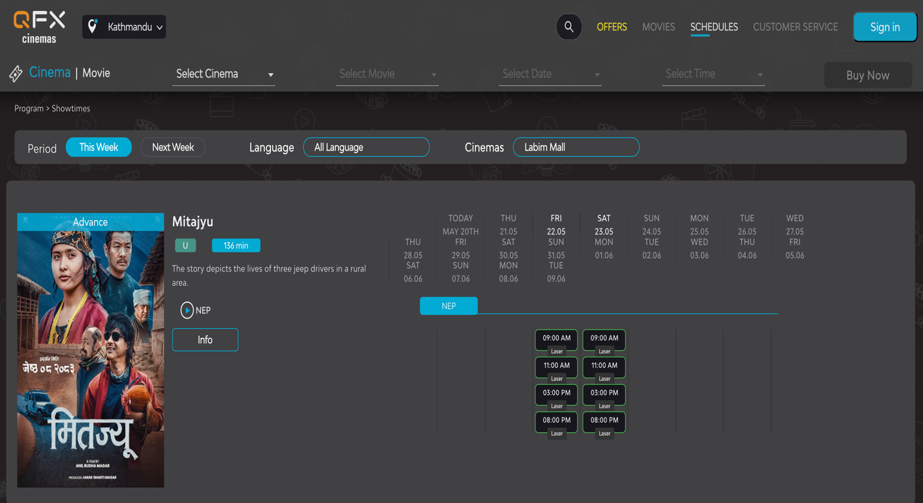

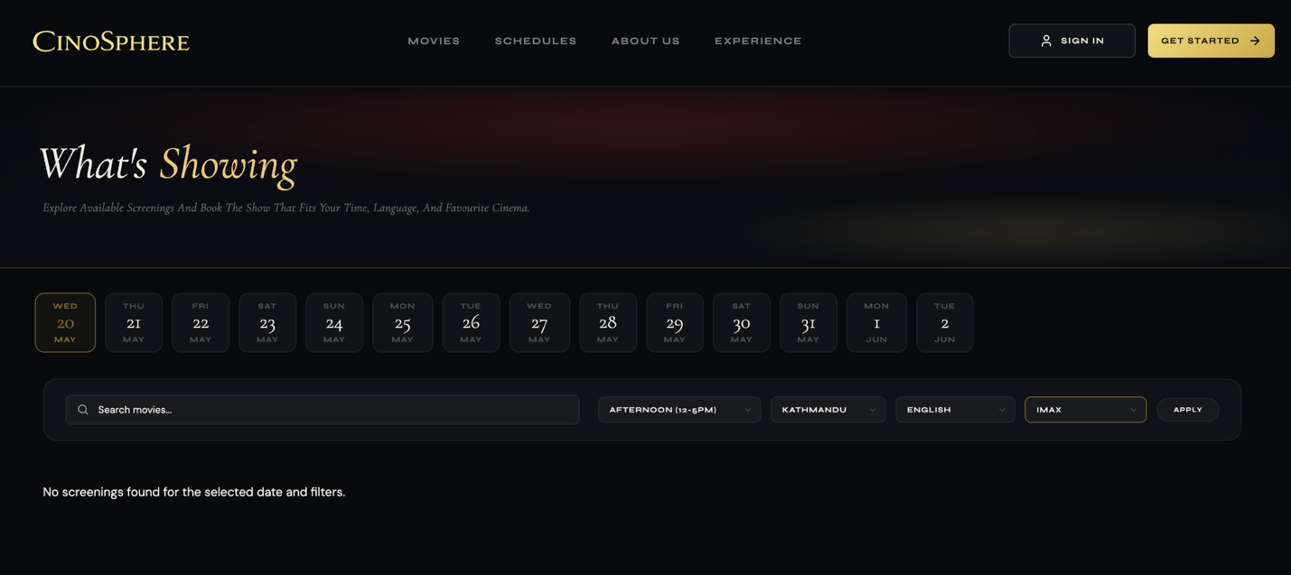

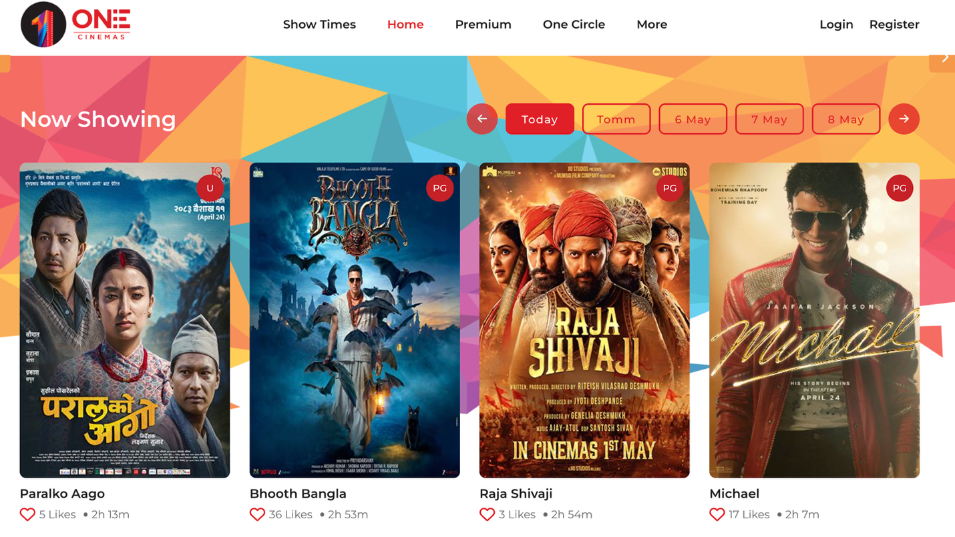

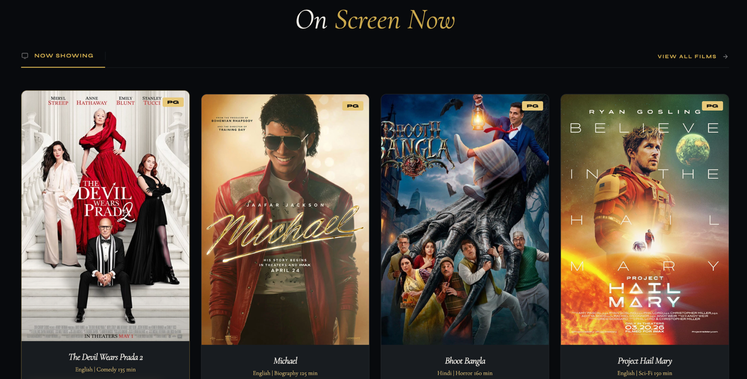

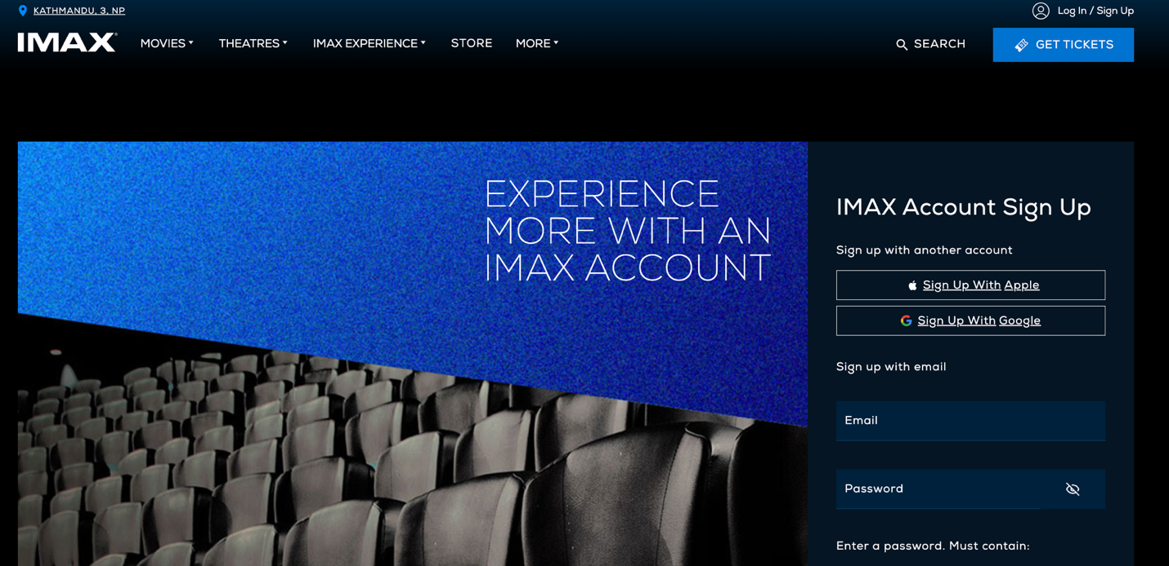

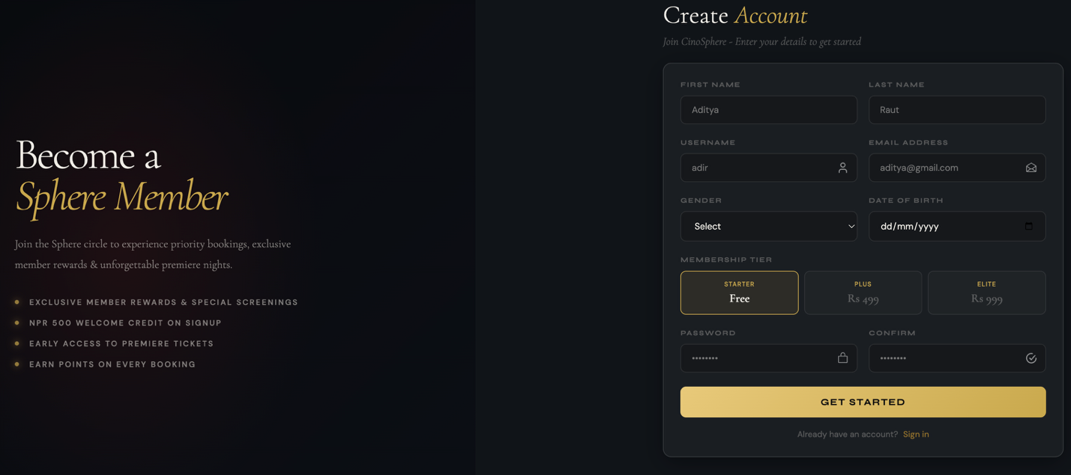

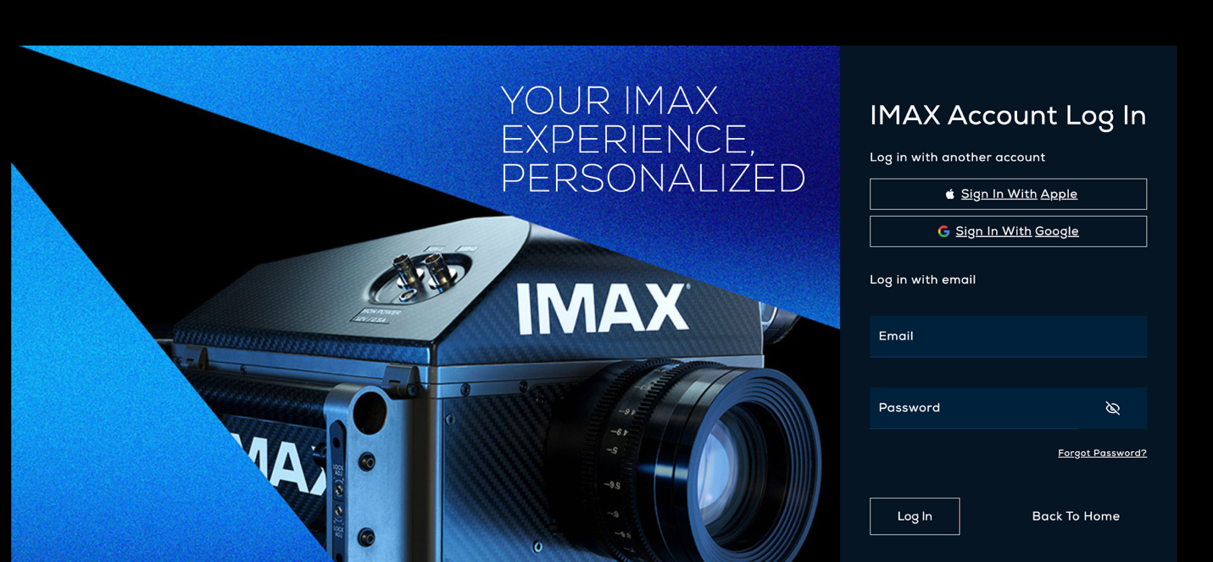

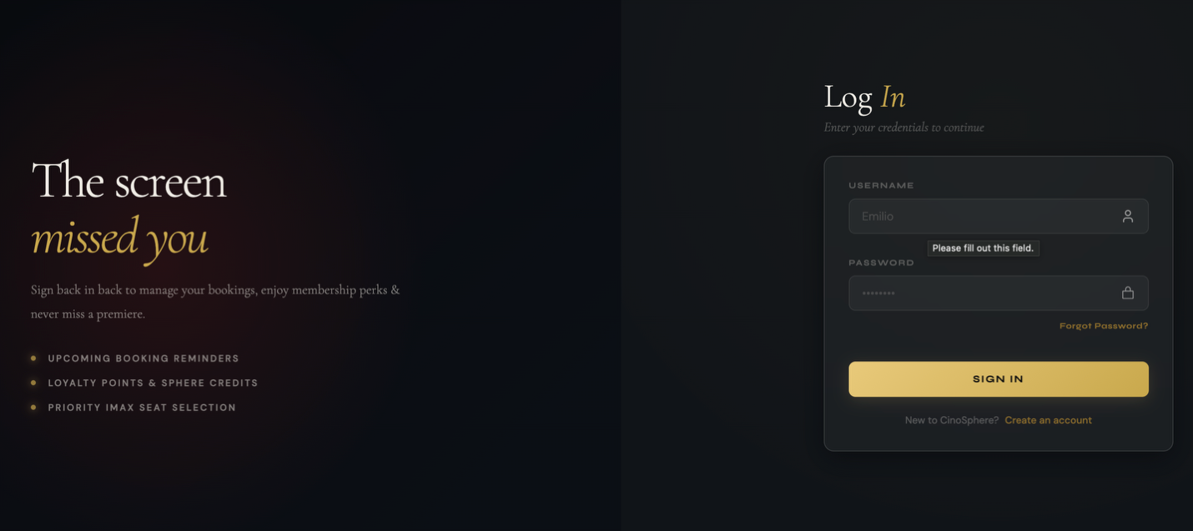

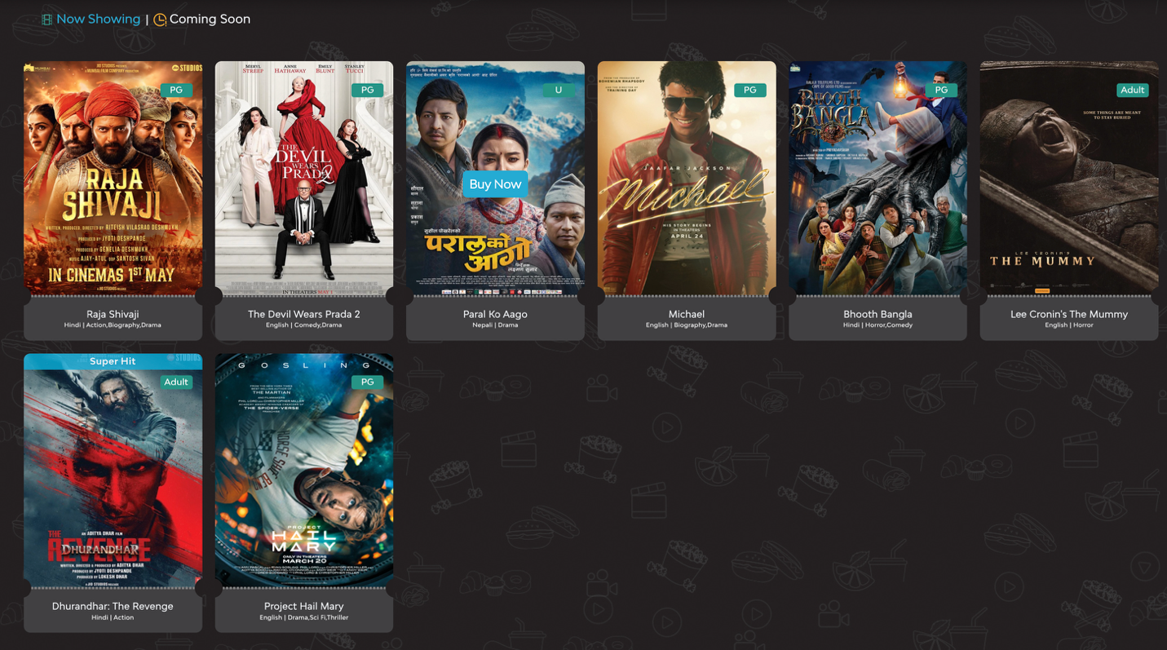

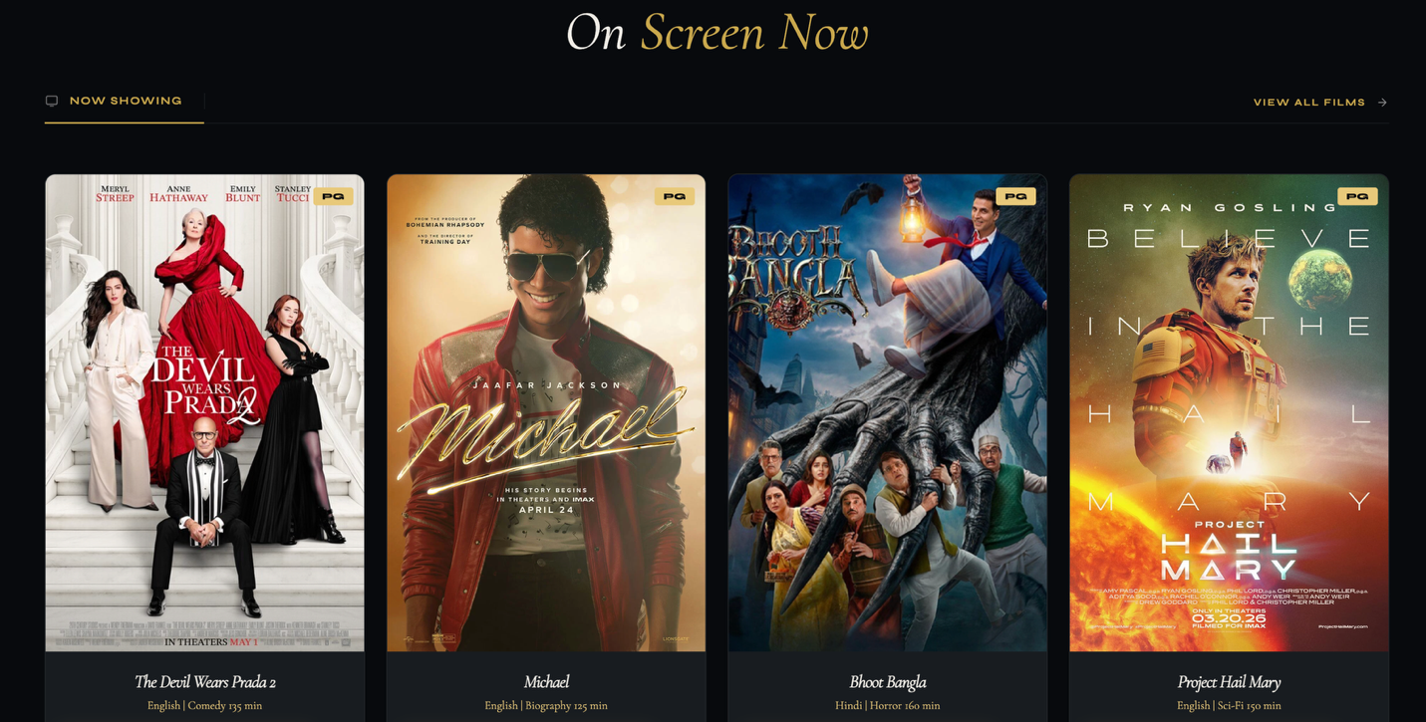

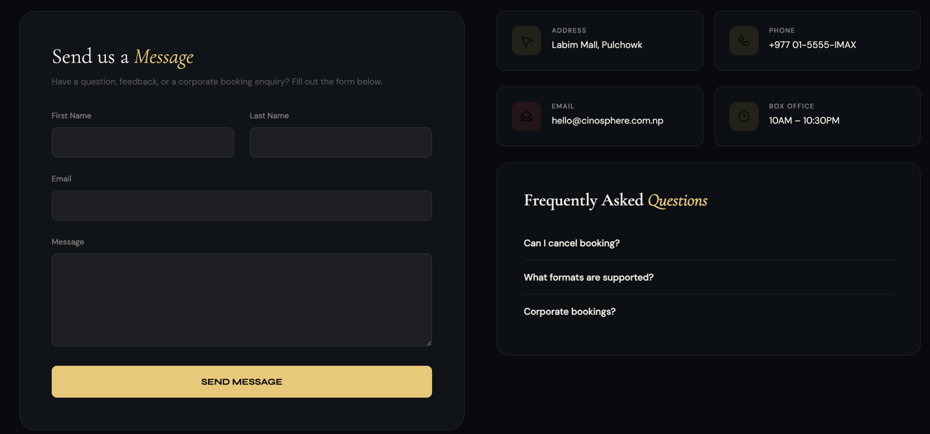

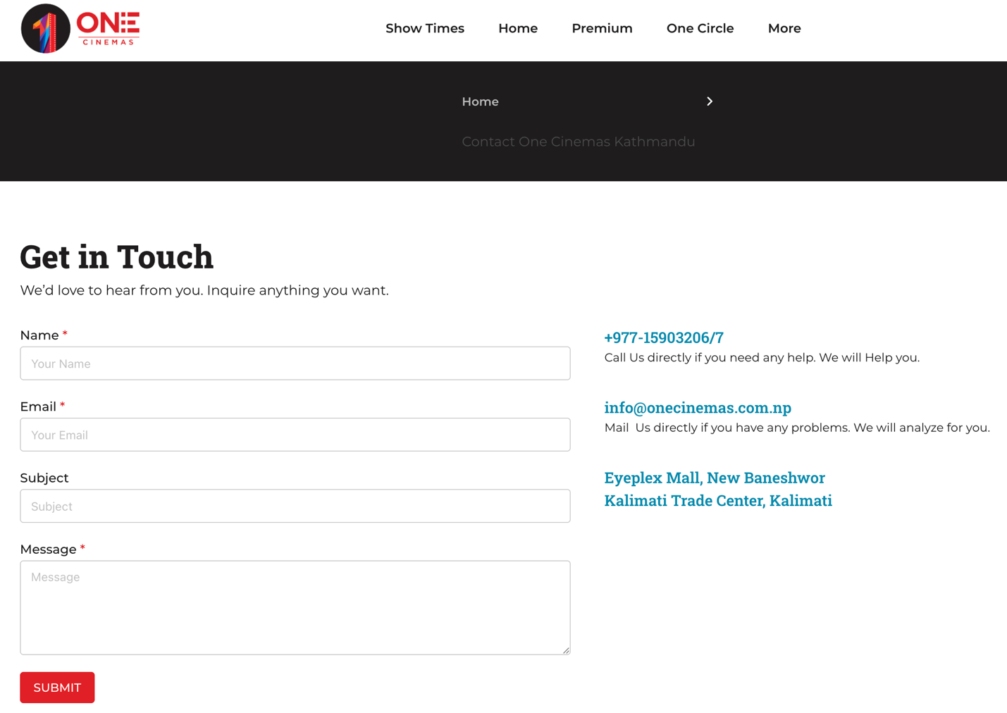

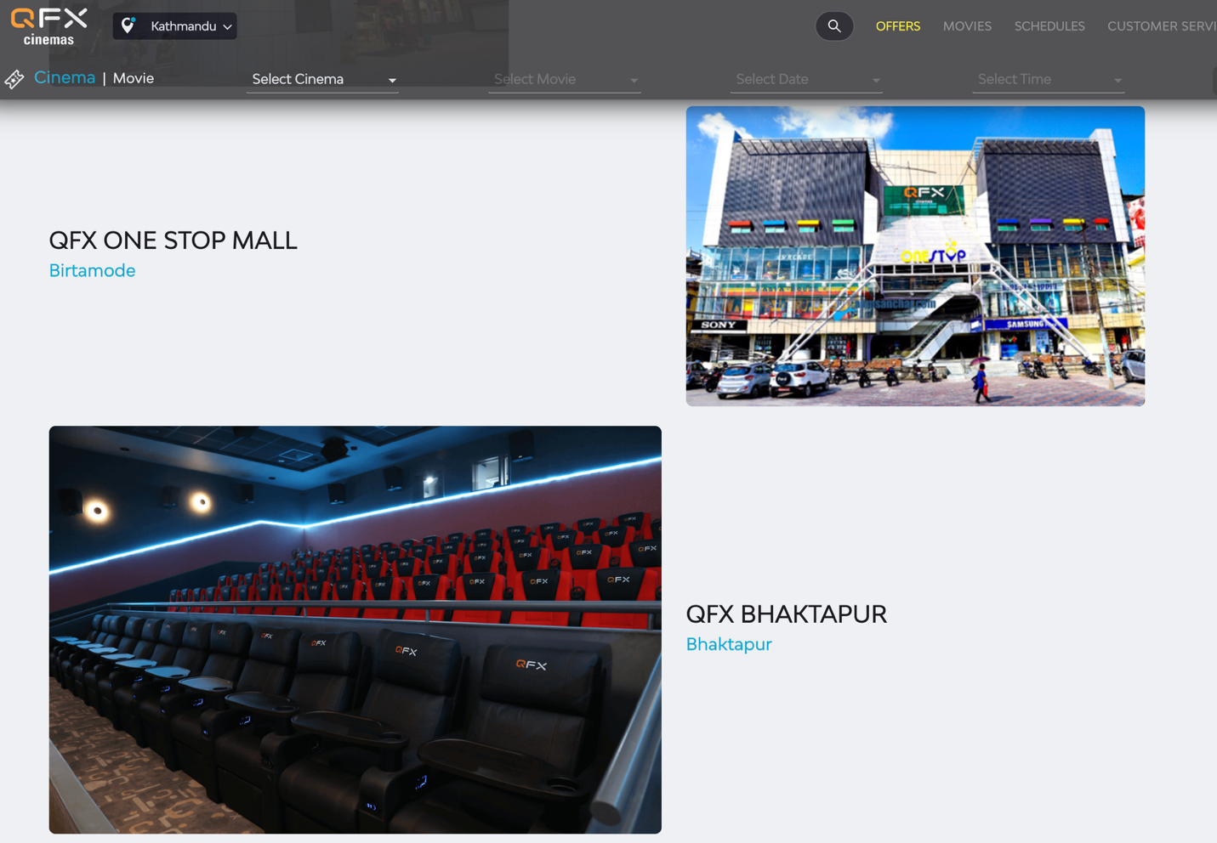
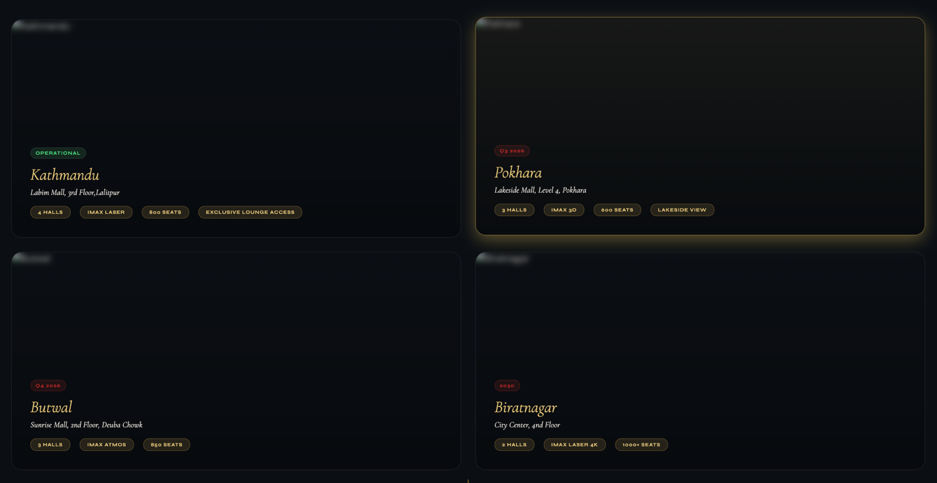

3.1.3Adopted Design Elements
This section conveys which features and elements were imitated for the CinoSphere system after the research and analysis process. Features like dark visuals, organized seat booking layouts, diagrammatic booking process, step-wise booking summary, organized sign up forms, navigation bars, use of metallic colors, and minimal structure were adopted from research platforms and redesigned to best fit to the branding and identity of CinoSphere. The intention of adopting these features was to give the user a smooth and memorable cinema experience while booking their tickets online, yet maintaining an authentic mood in the final system design
About Us



From QFX Cinemas, the main design aspect referenced for the About Us page is the display of branch locations with details. QFX Cinemas displays each of its branches as a separate listing with the name of the cinema, city and a photograph of either the building or the interior sofa seats. This concept of displaying the locations of physical cinema outlets on the About Us page of a cinema platform has been copied into CinoSphere, but CinoSphere has innovated on the way this information is presented.

While QFX simply lists the cinema name and location with a photo in a plain layout, CinoSphere presents each location as a Premium card with a status badge like "Operational" or Coming Soon "Q3 2026". Hall count, screen technology like IMAX Laser or IMAX 4D, seat count and Exclusive Lounge Access are highlighted with icons on each location card. This provides users with so much more information at a glance than the QFX locations list. The cards are styled with CinoSphere's black and gold branding, so this section doesn't look out of place on the website.

Schedules Page


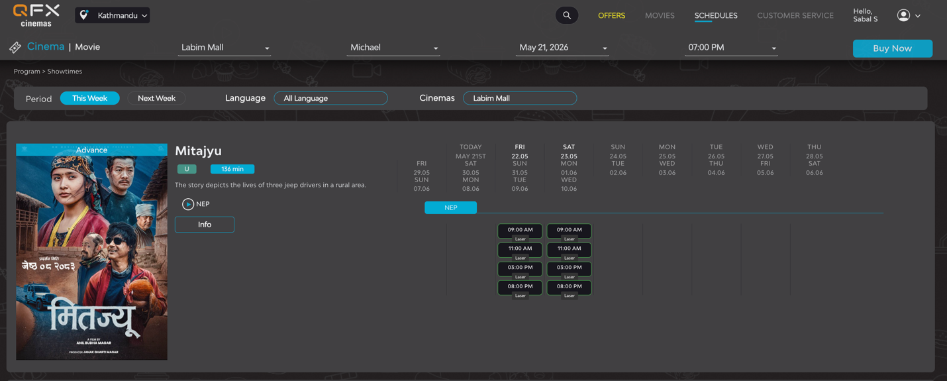
The main design aspect referenced from QFX Cinemas for the Schedules page is the horizontal date based navigation bar at the top of the page. QFX Cinemas displays upcoming dates in a horizontal scroll row, and users can click on a date to view the available show timings on that day. This concept has been exactly copied into CinoSphere, since it is clean and easy for users to use instead of a calendar to select dates. CinoSphere has improved this concept by displaying the day name, date and month as a whole for each date, instead of as 2 rows like in QFX. The second design aspect referenced from QFX in the Schedules page is the use of filters. QFX has provided filters bar for language and cinema location, whereas in CinoSphere filters have been provided for time slot such as Morning, Afternoon and Evening, city, language and screen such as IMAX and Standard. A search bar has also been included on the page which is absent in QFX, so users can search the name of a movie to filter results while filters are applied.

Movie Booking Page
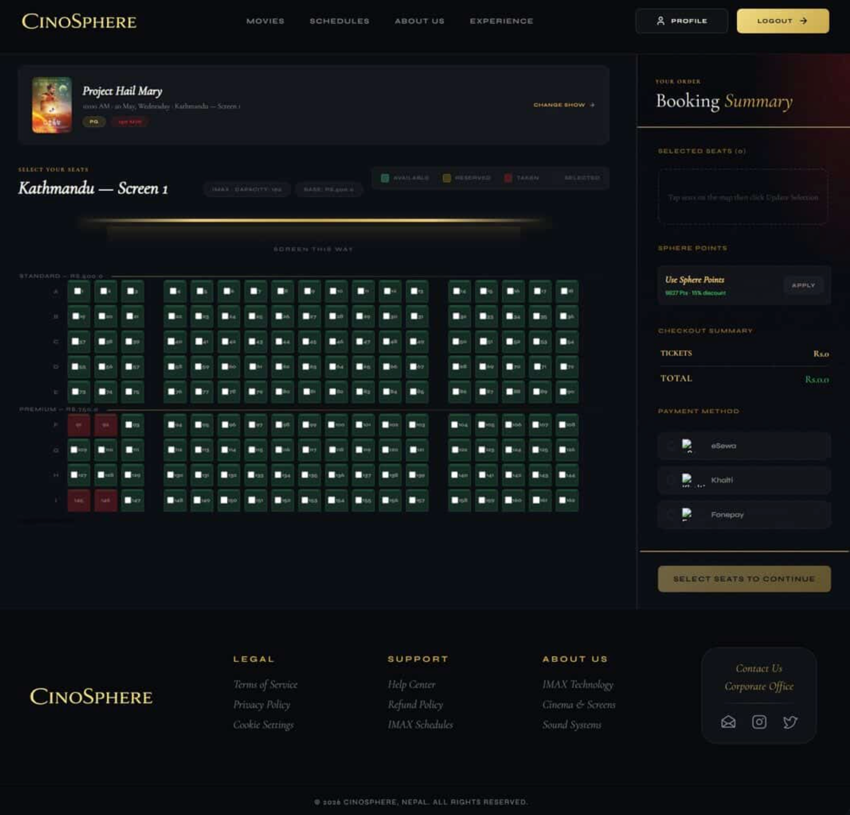
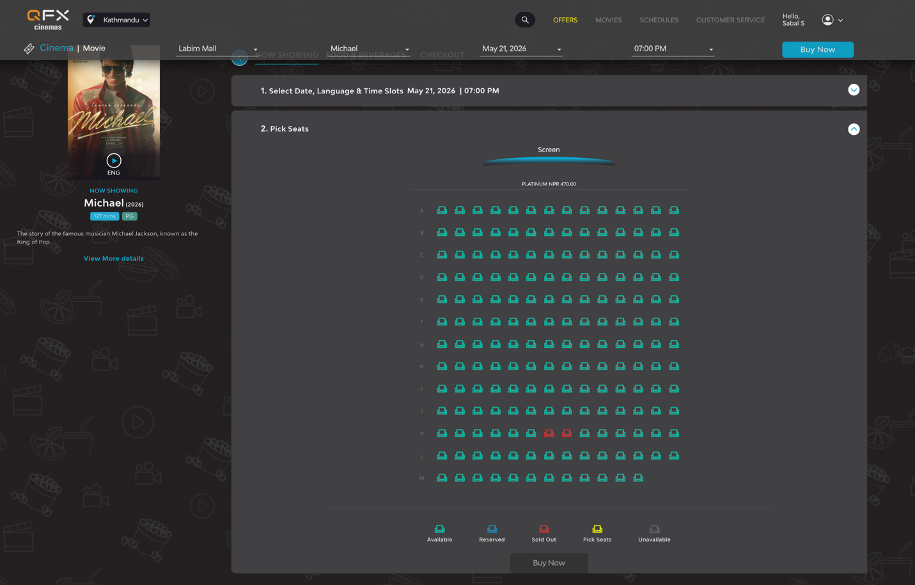
The design adopted for the process of movie booking in this website is a modern dark themed cinematic UI design, inspired from the process of movie booking on QFX Cinemas. We have followed a user centered, minimalistic design approach and made the process of ticket booking simple, interactive and visually pleasing for the users.The interface follows a grid based seat layout where different colors in the diagram represent available, reserved, selected and unavailable seats. A premium dark background with gold highlights has been used to give a luxurious, cinematic feel while keeping the seat selection process clearly understandable. Menu bars, movie details, screen positioning view, booking summary and payment sections have also been incorporated in an orderly fashion. The CinoSphere movie booking process has referenced the layout and booking flow followed by QFX cinema movie booking, but the look and feel, font and branding are completely distinct.

